**GB IMPORTANT QUESTIONS FOR MID-I**

# UNIT-I

1. Define Green Buildings. List out the objectives of Green Buildings and then briefly write about various Green Building rating systems in India.

**ANS**:

* A green building is defined as one which uses less water, optimizes energy efficiency, conserves natural resources, generates less waste and provides healthier space for occupants compared to conventional buildings.
* It is an environmentally sustainable building, designed constructed and operated to minimize total environmental impacts.
* A green building aims to lower environmental impacts, maximize social and economic value over a building life cycle through site selection, design, construction, operation, maintenance, renovation and demolition

**OBJECTIVES OF GREEN BUILDINGS:**

* **Reducing Environmental Impact:** Green buildings aim to minimize the consumption of resources such as energy, water, and raw materials. They also strive to reduce greenhouse gas emissions, waste generation, and pollution, thereby contributing to a more sustainable and healthier planet.
* **Energy Efficiency:** One of the primary objectives of green buildings is to enhance energy efficiency. They use innovative design techniques, insulation, energy-efficient appliances, lighting, and HVAC systems to significantly lower energy consumption. This reduces reliance on non-renewable energy sources and helps combat climate change.
* **Water Conservation:** Green buildings incorporate water-efficient fixtures, rainwater harvesting systems, and water recycling technologies to minimize water consumption. This helps conserve a precious resource and reduces the strain on local water supplies.
* **Improved Indoor Air Quality:** Green buildings prioritize indoor air quality by using low emission materials, proper ventilation systems, and natural lighting. This creates a healthier and more comfortable indoor environment for occupants, leading to increased productivity and well-being.
* **Optimal Site Selection and Land Use:** Sustainable buildings are often located in areas that minimize environmental impact, such as previously developed sites or areas with easy access to public transportation. They also promote responsible land use to preserve green spaces and biodiversity
* **Materials Selection:** Green buildings use eco-friendly and recycled materials whenever possible. The goal is to reduce the demand for new resources, lower waste generation, and decrease the environmental impact of construction and demolition.
* **Waste Reduction:** Through efficient design and construction practices, green buildings aim to minimize construction waste and encourage recycling. This reduces the amount of waste that ends up in landfills. θ Longevity and Durability: Green buildings are designed to have a longer lifespan and require less frequent maintenance and repairs. This minimizes the need for replacement materials and reduces the overall environmental impact over the building's lifetime.
* **Renewable Energy Integration:** Many green buildings incorporate renewable energy sources such as solar panels, wind turbines, and geothermal systems. This not only reduces the building's reliance on fossil fuels but also contributes excess energy back to the grid.
* **Occupant Health and Well-being:** Sustainable buildings prioritize the health and well-being of occupants by providing ample natural lighting, good ventilation, and comfortable indoor temperatures. These factors can lead to increased occupant satisfaction, productivity, and overall quality of life.
* **Cost Savings:** While the initial investment in green building technologies and materials can be higher, the long-term operational and maintenance cost savings often outweigh these costs. Energy and water savings, along with potential tax incentives, contribute to financial benefits over time.

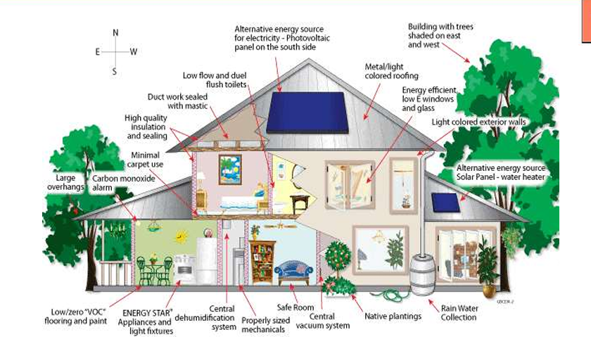

1. Elaborate the different types of energy. Discuss the various aspects to be followed for designing an Energy Efficient Building.

**ANS TYPES OF ENERGY**

• The word energy is derived from the Greek en (in) and ergon (work).

• Energy is defined as ‘the capacity to do work’– that is, the capacity to move an object against a resisting force.

• The scientific unit of energy is the joule.

• The concept of energy reveals the common features in processes as diverse as burning fuels, propelling machines and charging batteries.

• These and other processes can be described in terms of diverse forms of energy, including:

– Thermal Energy (Heat),

– Chemical Energy (In Fuels Or Batteries)

– Kinetic Energy (In Moving Substances)

– Electrical Energy

– Gravitational Energy

– Nuclear Energy

• General principles of energy efficient building design or low energy design comprise the following:

– Integration of energy concept from project outset, demand and management– Compact shape, minimize power requirement

– Day light design

– Energy efficient lighting, ventilation and space conditioning, site planning and landscape design

– Shading, green roof, building envelop

– Fenestration and window/ openings design , glazing design

– Efficient use of passive solar energy, renewable energy

– Energy efficient and easy to use technical systems

– Low water use sanitary ware

– Low energy electrical appliances

– Use of low embodied energy, recyclable construction materials possible

– Increased insulation, elimination of thermal bridges wherever

– Safety against fire and other hazards

1. Explain some key factors of better buildings and how do you reduce the energy consumption for a Green Building design.

**ANS** BETTER BUILDING

When it comes to better building, several factors play a crucial role in ensuring the quality, efficiency, and sustainability of the construction. Some key factors to consider are:

**1. Planning and Design:** Thorough planning and thoughtful design are essential for a successful building project. This includes understanding the purpose of the building, its intended use, and the needs of the occupants. Consider factors such as functionality, aesthetics, space utilization, and energy efficiency during the design phase.

**2. Quality Materials:** Using high-quality materials is vital for the durability and longevity of a building. Quality materials not only enhance the structural integrity but also reduce maintenance costs over time. Choose materials that are resistant to weathering, fire, pests, and other potential hazards.

**3. Energy Efficiency:** Building energy-efficient structures is not only environmentally friendly but also helps reduce long-term operating costs. Incorporate energy-efficient design elements such as proper insulation, efficient HVAC systems, energy-saving lighting, and the use of renewable energy sources like solar panels.

**4. Sustainable Construction:** Sustainable building practices aim to minimize the environmental impact throughout the entire construction process. Consider using eco friendly materials, incorporating green building techniques, recycling and reusing materials, and implementing water-saving measures.

**5. Structural Integrity:** A structurally sound building is essential for the safety of its occupants. Ensure that the building adheres to local building codes and regulations. Qualified architects and engineers to design and oversee the construction to guarantee its structural integrity.

**6. Proper Ventilation:** Good indoor air quality is crucial for occupant health and comfort. Incorporate proper ventilation systems that provide fresh air circulation and minimize the buildup of pollutants and moisture, which can lead to mold and other issues.

**7. Accessibility:** Design the building to be accessible to people of all abilities. Incorporate features such as ramps, elevators, wider doorways, and accessible restrooms to ensure easy access for individuals with disabilities.

**8. Safety and Security:** Adequate safety measures throughout the building, including fire safety systems, emergency exits, smoke detectors, and security systems. Ensure compliance with safety regulations and consider factors like slip-resistant surfaces and proper lighting.

**9. Maintenance and Durability:** Plan for ease of maintenance and longevity of the building. Incorporate durable materials that require minimal upkeep and select systems and components that are easily accessible for repairs and replacements.

**10. Environmental Considerations:** Evaluate the environmental impact of the building throughout its lifecycle, including construction, operation, and eventual demolition. Aim to minimize waste generation, water usage, and energy consumption while maximizing recycling and sustainability practices.

**______________________________________________________________________**

1. In the pursuit of better buildings, what are some innovative approaches that have proven effective in reducing energy consumption in the Indian building sector? Elaborate.

**ANS** **REDUCING ENERGY CONSUPMTION**

Reducing energy consumption is an important step towards sustainability and cost

savings. Here are some effective ways to reduce energy consumption:

**1. Improve insulation:** Properly insulate your home or office to prevent heat transfer, especially in walls, windows, and roofs. This helps maintain a consistent temperature

indoors and reduces the need for heating or cooling systems.

**2. Upgrade to energy-efficient appliances:** Replace old appliances, such as refrigerators, air conditioners, heaters, and light bulbs, with energy-efficient models. Check the Energy Star label, as these products meet strict energy efficiency guidelines.

**3. Use natural lighting:** Take advantage of natural daylight by opening curtains or blinds during the day instead of relying on artificial lighting. Use lighter colors for walls and furniture to reflect more light and reduce the need for artificial lighting.

**4. Adjust thermostat settings:** Lower your heating thermostat by a few degrees in winter and raise it by a few degrees in summer. This small change can significantly reduce energy consumption without sacrificing comfort.

**5. Unplug electronics when not in use:** Many devices and appliances continue to consume energy even when they are turned off but still plugged in. Unplug chargers, TVs, computers, and other electronics when they are not in use, or use power strips with switches to easily turn off multiple devices at once.

**7. Use energy-efficient lighting:** Replace traditional incandescent light bulbs with

energy-efficient options such as compact fluorescent lamps (CFLs) or light-emitting

diodes (LEDs). These bulbs consume significantly less energy and last longer.

**8. Reduce phantom loads:** Many electronic devices and appliances draw power even when not in use, known as phantom loads. Use power strips with switches to completely disconnect power supply when devices are not in use.

**9. Optimize water heating:** Lower the temperature of your water heater to around 120 degrees Fahrenheit (49 degrees Celsius) to save energy. Insulate your water heater and the hot water pipes to reduce heat loss.

**10. Practice efficient cooking and laundry:** Use the microwave or toaster oven instead of the oven whenever possible, as they consume less energy. Wash laundry in cold water and hang dry when feasible. Only run full loads in the dishwasher and air dry the dishes.

**11. Install programmable thermostats:** Programmable thermostats allow you to set specific temperature settings for different times of the day, adjusting the temperature automatically. This ensures efficient energy usage when you are away or asleep.

**12. Educate and involve occupants:** Raise awareness about energy conservation among family members, coworkers, or employees. Encourage them to adopt energy-saving habits, such as turning off lights, using natural light, and unplugging devices.

**To promote energy efficiency at building level and at city level the following aspects need to be considered**

• Daylight design of building with natural ventilation, green roof and passive climate design

• Adoption of BEE Guidelines, EC building code, Standards and specifications for

buildings, energy and equipments.

• Promoting the utilization of exhaust heat from incinerations plants and sewerage

treatment

• Unser renewable energy for buildings, street lighting, hoardings, mass cooking,

climate controls

• Replace coal-based power generation to natural gas/non-polluting alternative fuels

• Observe strictly safety controls and instructions

• Check transmission and distribution losses

• Incentive decentralized power generation and energy conservation

• Various passive techniques have been put in perspective, and energy saving passive strategies can be seen to reduce interior temperature and increase thermal comfort, reducing air conditioning loads.

• In regions where heating is important during winter months, the use of top-light solar passive strategies for spaces without an equator-facing façade can efficiently reduce energy consumption for heating, lighting and ventilation.

__________________________________________________________________

1. How does energy efficiency in buildings contribute to reducing pollution?

**ENRGY EFFIECINCY AND POLLUTION CONTROL:**

**1. Design and Orientation:**

❑ Optimize the building's design and orientation to maximize natural light and reduce the need for artificial lighting.

❑ Consider passive solar design principles to harness natural heat and ventilation.

❑ Use shading devices, such as awnings or louvers, to minimize direct sunlight and reduce cooling loads.

**2. Energy-Efficient Lighting:**

❑ Install energy-efficient lighting systems, such as light levels based on occupancy and natural light availability.

**3. HVAC Systems:**

❑ LEDs, which consume less energyand have a longer lifespan than traditional bulbs.

❑ Incorporate occupancy sensors and daylight sensors to automatically adjust lighting

❑ Use high-efficiency HVAC (heating, ventilation, and air conditioning) systems that meet or exceed energy efficiency standards.

❑ Implement zoned heating and cooling systems to optimize energy use in different areas of the building.

❑ Regularly maintain and clean HVAC systems to ensure optimal performance.

**4. Insulation and Sealing:**

❑ Insulate the building's envelope, including walls, roof, and windows, to minimize heat transfer and improve energy efficiency.

❑ Sealair leaks and use weatherstripping to prevent drafts and enhance thermal comfort.

**5. Energy-Efficient Appliances and Equipment:**

❑ Install energy-efficient appliances, such as refrigerators, dishwashers, and washing machines, that carry the ENERGY STAR label.

❑ Useenergy-efficient office equipment and electronics, including computers and printers

**6. Renewable Energy Sources:**

❑ Install renewable energysystems like solar panels or wind turbines to generate electricity.

❑ Consider incorporating geothermal systems for heating and cooling, utilizing the constant temperatureof the earth.

**7. Water Conservation:**

❑ Implement water-efficient fixtures and appliances, such as low-flow faucets, showerheads, and toilets. Capture and reuse rainwater for landscaping or non-potable uses like flushing toilets or irrigation.

**8. Indoor Air Quality (IAQ):**

❑ Use low-VOC (volatile organic compounds) materials, paints, and furniture to improve indoor air quality. Install effective ventilation systems to provide fresh air circulation and reduce the concentration of pollutants indoors.

__________________________________________________________________

# UNIT-II

1. Differentiate between Active and Passive Solar Energy Design. Explain the Direct method of Passive Solar Heating with a neat sketch.

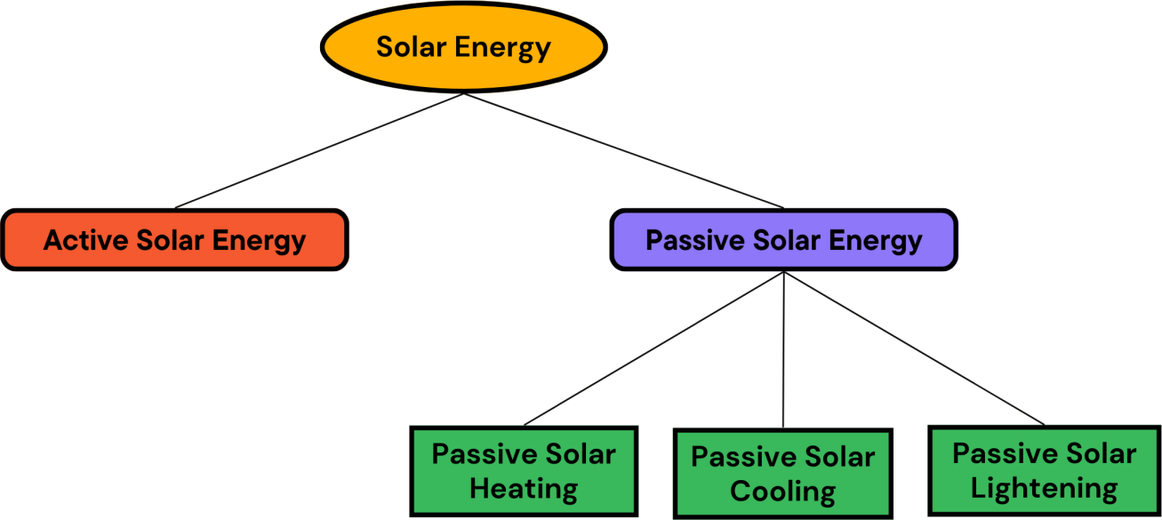

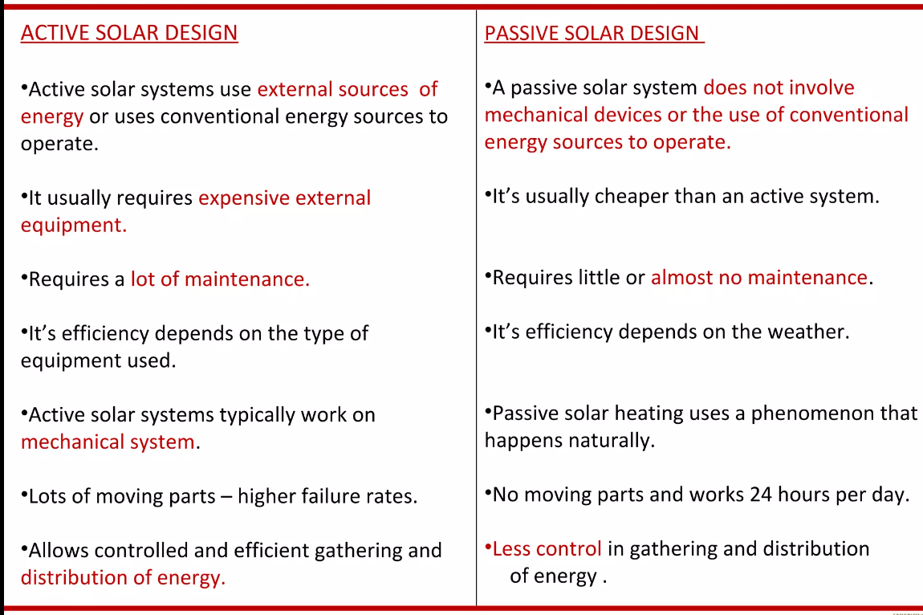

**Methods of Passive Solar Heating:**

1. **Direct method**

* In the direct gain system, the living space collects, absorbs, and distributes the sun’s heat energy.
* The south-facing glass allows solar energy into the living space, where it directly and indirectly strikes thermal mass materials like [masonry walls](https://theconstructor.org/building/building-material/types-of-masonry-walling-materials/45598/) and floors.
* The thermal mass takes solar radiation during the daytime and emits heat energy at night into the living space. The direct gain uses around 60-75% of the sun’s heat that strikes the window.

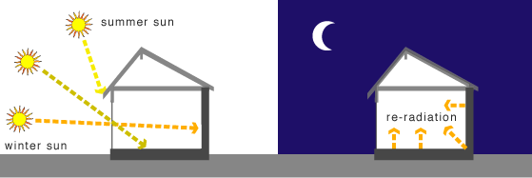

__________________________________________________________________

1. **Classify and explain in detail about Solar PV Generating Systems.**

***Types of Solar PV Generating System:***

When photovoltaic modules are exposed to sunlight, they generate electricity in d.c. waveform. PV power generating systems can broadly be classified into two

1. On-Grid Solar Energy System (Grid connected solar PV system)
2. Off-Grid Solar Energy System (Stand alone solar PV system)

**i. On-Grid Solar Energy System:**

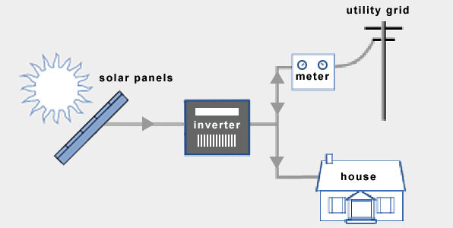

An on-grid solar energy system, also known as a grid-tied solar system or grid-connected solar system, is a type of solar power installation that is connected to the electrical grid. In this setup, the solar panels generate electricity from sunlight, and the generated electricity can be used to power your home or business while also being able to interact with the grid.

Here's how an on-grid solar energy system works:

* + 1. ***Solar Panels:*** Photovoltaic (PV) panels are installed on your rooftop or on a suitable area with exposure to sunlight. These panels contain multiple solar cells that convert sunlight into direct current (DC) electricity.
    2. ***Inverter:*** The DC electricity produced by the solar panels is sent to an inverter. The inverter's primary function is to convert the DC electricity into alternating current (AC), which is the type of electricity used in homes and businesses.
    3. ***Power Consumption:*** The AC electricity produced by the inverter can be used to power your electrical appliances, lights, and other devices in your home or business.

4. ***Grid Interaction:***

* + ***Electricity Usage:*** If your solar panels generate more electricity than you're currently using, the excess electricity is sent back to the grid. This can potentially result in a credit on your electricity bill, as you might be compensated for the surplus energy you contribute to the grid. This process is known as net metering.
  + ***Electricity Shortage:*** On the other hand, if your electricity consumption exceeds the amount produced by your solar panels (such as during cloudy days or at night), you can draw electricity from the grid to meet your needs.

5. ***Metering:*** A bidirectional meter is installed that measures both the electricity you consume from the grid and the electricity you send back to the grid. This enables accurate tracking of your energy usage and generation.

6. ***Electricity Billing:*** Your electricity bill is calculated based on the net difference between the electricity you consume from the grid and the electricity you contribute back to the grid. This means that you only pay for the "net" electricity you use after accounting for your solar generation.

**Advantages:**

1. ***Cost Savings:*** On-grid solar systems allows to generate electricity, reducing electricity bills as it rely on the energy produced by your solar panels.

2. ***Net Metering:*** Many regions offer net metering, allowing you to sell excess electricity back to the grid, earning you credits or payments. This further enhances cost savings.

3. ***Low Maintenance:*** On-grid systems require less maintenance. Regular cleaning and occasional inspection are usually sufficient to keep them functioning efficiently.

4. ***Environmental Benefits:*** Solar energy is clean and renewable, producing no greenhouse gas emissions or pollutants.

5. ***Ease of Installation:*** On-grid systems are relatively straightforward to install, as they don't require batteries for energy storage, simplifying the setup process.

**Disadvantages:**

1. ***Grid Dependence:*** On-grid systems are connected to the utility grid. It rely on the grid during nighttime or cloudy periods when solar panels aren't generating enough energy.

2. ***No Backup Power:*** Since on-grid systems lack energy storage (batteries), So no power during grid outages. It is a significant drawback in areas with unreliable power supply.

3. ***Initial Costs:*** While solar panel costs have decreased over time, the initial investment for installing solar panels and necessary equipment can still be substantial.

6. ***Environmental Impact of Grid:*** The electricity grid itself might still rely on non-renewable sources, which could diminish the overall environmental impact reduction.

**ii. Off Grid Solar Energy System:**

An off-grid solar energy system operates independently from the utility grid, providing electricity to a location without relying on external power sources. Here's how an off-grid solar energy system works:

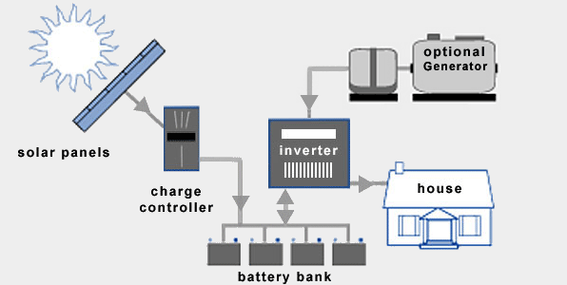

* + 1. ***Solar Panels:*** The system starts with solar panels, which are installed on a suitable location like a roof or ground. These panels capture sunlight and convert it into direct current (DC) electricity using photovoltaic (PV) cells.
    2. ***Charge Controller:*** The DC electricity generated by the solar panels is then sent to a charge controller. The charge controller's main function is to regulate the charging of batteries and prevent overcharging, which can damage the batteries.
    3. ***Battery Bank:*** Energy generated by the solar panels is stored in a battery bank. These batteries store excess energy produced during sunny periods so that it can be used when the sun is not shining, such as during nighttime or cloudy days.
    4. ***Inverter:*** Energy stored in batteries is in the form of DC electricity. Most household appliances and electronics require alternating current (AC) electricity to function. An inverter is used to convert the stored DC electricity into usable AC electricity.
    5. ***AC Loads:*** The AC electricity produced by the inverter can now be used to power various appliances, lights, and electronics in your off-grid location.
    6. ***Backup Generator (Optional):*** In regions with limited sunlight or high energy demands, an optional backup generator might be integrated into the system. This generator can provide electricity during prolonged periods of low solar output or when the battery bank is depleted.

**Advantages:**

1. ***Grid Independence:*** These systems provide complete independence from the utility grid, making them ideal for remote locations or areas with unreliable grid access.

2. ***Energy Backup:*** With a battery bank for energy storage, off-grid systems can provide consistent electricity even during cloudy days or nighttime.

3. ***Environmental Benefits:*** Off-grid systems use clean and renewable solar energy, reducing reliance on fossil fuels and lowering carbon emissions.

**Disadvantages:**

***1. Higher Initial Costs:*** Setting up an off-grid system involves purchasing solar panels, batteries, inverters, and other components, which can be expensive upfront.

***2. Limited Energy Storage:*** Capacity of battery banks determines how much energy can be stored for cloudy days or at night. Oversizing the battery bank increases costs.

***3. Maintenance:*** Batteries in off-grid systems require regular maintenance, including monitoring water levels (for lead-acid batteries) and occasional replacements.

***5. Space Requirements:*** To generate enough energy, you might need a larger number of solar panels, requiring adequate space for installation.

***6. Backup Generation (Optional):*** In some cases, an off-grid system might need backup generators, which can introduce additional maintenance and fuel costs.

__________________________________________________________________

1. What is Rain Water Harvesting? Explain the process of Rain water Harvesting with neat sketch and also mention the advantages and disadvantages of it.

**RAIN WATER HARVESTING**

Rainwater harvesting is the practice of collecting, storing, and using rainwater for various purposes, such as irrigation, domestic use, and groundwater recharge. This sustainable water management technique helps reduce reliance on traditional water sources and conserves freshwater resources.

* To supplement the ever growing shortage of protected, pure and safe water supply for human consumption, rainwater is an ideal source which can be conserved and used in a useful manner by the people.
* Two major systems that are ideal for urban and semi-urban developed areas are:

1. Artificial ground water recharge and
2. Roof top rainwater harvesting

**a) Artificial ground water recharge:**

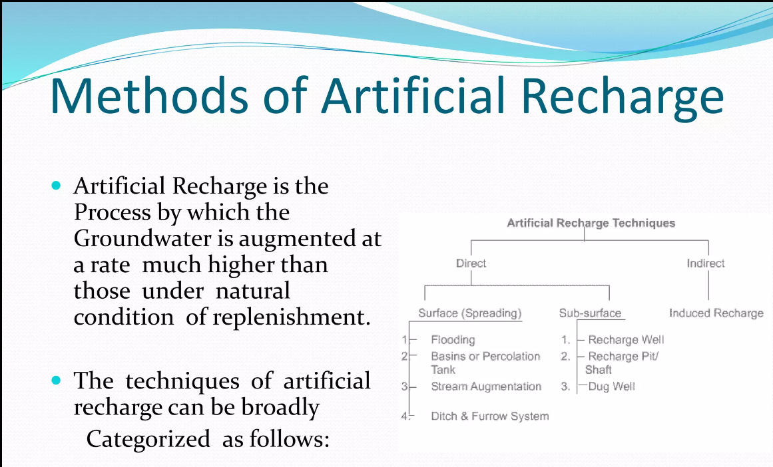

1. **Roof Rain Water Harvesting:**

Roof rainwater harvesting is a common and effective method of collecting rainwater from rooftops and storing it for various uses.

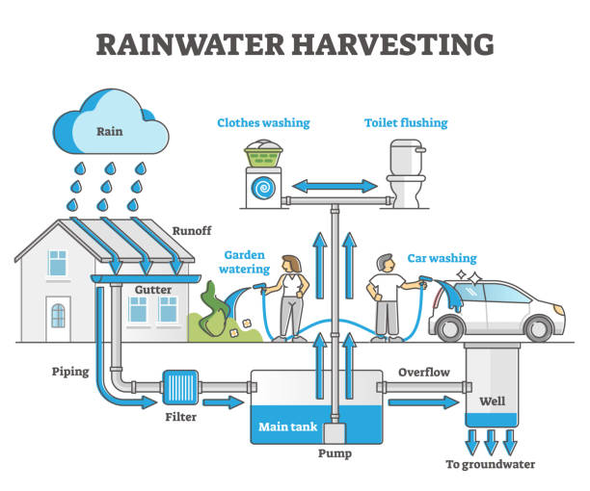

***1. Catchment Area:*** The first step is to identify the catchment area, which is the surface where rainwater will be collected. In this case, it's the rooftop of a building. The catchment area's size and design determine how much rainwater can be harvested.

***2. Conveyance System:*** Gutters and downspouts are installed along the edges of the rooftop to channel rainwater from the catchment area to the storage system. The gutters collect the rainwater and direct it towards the downspouts.

***3. First-Flush Diverter (Optional):*** In some systems, a first-flush diverter is installed in the downspout. This device ensures that the initial runoff, which might contain debris and contaminants from the roof, is diverted away before allowing clean rainwater to enter the storage system.

***4. Filtration:*** A filtration mechanism, such as mesh screens or sediment filters, is usually installed along the conveyance path or before the water enters the storage tank. This filtration removes leaves, debris, and other particles from the rainwater. Types of Filters are Sand Filter, Charcoal filter, PVC pipe filter and Sponge filter.

***5. Storage Tanks:*** The filtered rainwater is collected in storage tanks or cisterns. These tanks can be made of various materials, including plastic, concrete, or metal. The tanks can be located above ground or buried underground, depending on available space and design preferences.

***6. Overflow System:*** To prevent overflow and flooding, an overflow system is installed. Excess rainwater that cannot be stored is diverted away from the storage tanks and led to a suitable drainage area.

***7. Distribution System:*** When the stored rainwater is to be used, it can be pumped or gravity-fed from the storage tank to its intended end uses. This might include irrigation, toilet flushing, laundry, or even treated for potable use, depending on the system's design and water quality.

**Advantages of Rainwater Harvesting:**

1. ***Conservation of Freshwater:*** Rainwater harvesting reduces the demand for traditional water sources like rivers and groundwater.

2. ***Self-Sufficiency:*** It promotes self-sufficiency in water supply, particularly in areas with unreliable or limited access to municipal water.

3. ***Reduced Runoff and Flooding:*** Collecting rainwater reduces stormwater runoff, which can contribute to urban flooding and erosion.

4. ***Cost Savings:*** Using harvested rainwater for non-potable purposes like irrigation or toilet flushing can lead to reduced water bills.

5. ***Environmentally Friendly:*** Rainwater harvesting helps reduce the strain on local water bodies and ecosystems, supporting biodiversity.

6. ***Groundwater Recharge:*** Properly managed rainwater harvesting systems can contribute to groundwater recharge by allowing rainwater to infiltrate the soil and replenish aquifers.

**Challenges and Considerations:**

1. ***Rainfall Patterns:*** The effectiveness of rainwater harvesting depends on the local climate and the frequency and amount of rainfall.

2. ***Initial Costs:*** Installing rainwater harvesting systems can involve initial expenses for components such as storage tanks, filtration systems, and plumbing.

3. ***Maintenance:*** Regular maintenance is necessary to clean filters, check for leaks, and ensure the stored rainwater remains safe for its intended uses.

4. ***Water Quality:*** Proper filtration and treatment are essential to ensure the harvested rainwater is safe for consumption or other uses.

5. ***Regulations:*** Some regions have regulations governing the collection and use of rainwater, especially for potable purposes.

__________________________________________________________________

1. How the wind energy is harnessed to generate the power? Explain with a neat sketch.

**WIND AND OTHER RENEWABLES:**

**1. WIND POWER ENERGY:**

Wind power energy, commonly referred to as wind energy, is a renewable energy source derived from the kinetic energy of moving air. It is harnessed using wind turbines, which convert the mechanical energy of the wind into electrical energy that can be used for various purposes, such as electricity generation for homes, businesses, and industries.

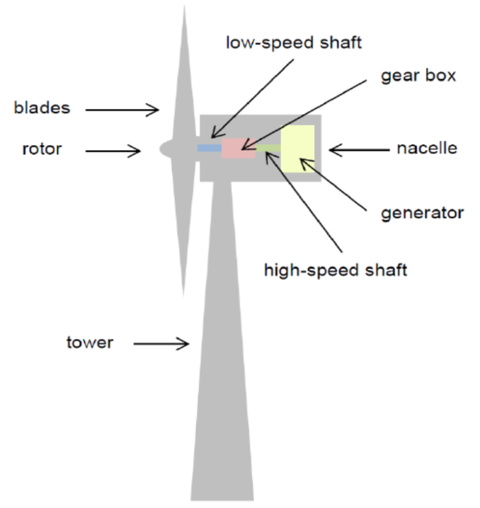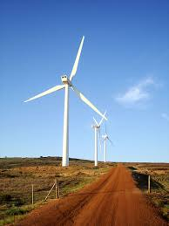

Here's how wind energy works:

**1. Wind Turbines:** Wind turbines are the primary technology used to capture wind energy. These structures consist of several key components:

* 1. ***Rotor* *Blades*:** Large, aerodynamically designed blades capture the kinetic energy of the wind.
  2. ***Rotor* *Hub*:** Central component that connects the rotor blades to the main shaft.
  3. ***Generator*:** Converts the rotational motion of the main shaft into electrical energy.
  4. ***Nacelle*:** It is the housing that contains the generator, gearbox, and other mechanical components.
  5. ***Tower:*** Supports the rotor and nacelle, elevating them to a height where stronger and more consistent winds are found.

**2. Wind Conversion:** When the wind blows, it causes the rotor blades to rotate. This rotational motion is transferred to the generator through the main shaft. Inside the generator, electromagnetic induction creates an electrical current, which is then collected and transmitted to the power grid for distribution.

**3. Wind Speed and Power Output:** The power output of a wind turbine is proportional to the cube of the wind speed. This means that even a small increase in wind speed can lead to a significant increase in power generation. Wind turbines are designed to start generating electricity at a certain minimum wind speed (cut-in speed) and to shut down at a higher wind speed (cut-out speed) to prevent damage.

**Advantages of Wind Energy:**

* + ***Renewable:*** Wind energy is a renewable resource, meaning it won't deplete as long as the Earth's atmosphere continues to have wind patterns.
  + ***Low Environmental Impact:*** Wind power has a relatively low environmental impact compared to fossil fuels, as it produces no greenhouse gas emissions during operation.
  + ***Reduced Water Usage:*** Wind turbines require very little water for their operation, unlike many conventional power plants.
  + ***Local Economic Benefits:*** Wind farms can provide economic benefits to local communities through job creation, land lease payments, and increased tax revenue.

**Challenges and Considerations:**

* + ***Intermittency:*** Wind energy generation is intermittent, as it depends on wind availability. Energy storage solutions and a diverse energy mix are often used to mitigate this challenge.
  + ***Visual and Noise Concerns:*** Some people have concerns about the visual impact and noise generated by wind turbines, particularly in densely populated areas.

***Infrastructure and Permitting:*** Developing wind projects requires suitable infrastructure, transmission lines, and permits, which can involve regulatory challenges.

__________________________________________________________________

1. Explain the various applications of Renewable Energy Sources in Green Building Design with Examples.

**RENEWABLE ENERGY SOURCES USED IN GREEN BUILDINGS:**

Green buildings aim to minimize their environmental impact by utilizing sustainable and renewable energy sources. Here are some renewable energy sources commonly used in green buildings:

**1. Solar Power:** Solar energy is a popular choice for green buildings. Photovoltaic (PV) panels are installed on rooftops or integrated into building materials to capture sunlight and convert it into electricity.

**2. Wind Power:** Wind turbines can be installed on-site or nearby to harness wind energy and generate electricity. They are particularly effective in locations with consistent and strong wind patterns.

**3. Geothermal Energy:** Geothermal systems utilize the stable temperature underground to provide heating, cooling, and hot water for buildings. Heat pumps extract geothermal energy from the earth and distribute it throughout the building.

**4. Biomass:** Biomass energy utilizes organic materials like wood pellets, agricultural waste, or dedicated energy crops to produce heat or electricity through combustion or conversion processes. Biomass boilers or combined heat and power (CHP) systems are common in green buildings.

**5. Hydropower:** Small-scale hydropower systems can be incorporated into buildings that are near a water source, such as rivers or streams. They use the flow of water to generate electricity through turbines.

**6. Tidal Energy:** In coastal areas with strong tidal currents, tidal energy converters can be used to generate electricity. These devices harness the kinetic energy of the tides and convert it into usable power.

**7. Micro Combined Heat and Power (CHP):** CHP systems simultaneously generate electricity and useful heat from a single fuel source, such as natural gas or biomass. They are efficient and can reduce overall energy consumption.

**8. Fuel Cells:** Fuel cells produce electricity through an electrochemical process, often using hydrogen as the fuel source. They can be used in green buildings to provide clean and reliable power, with water and heat as byproducts.

These renewable energy sources can be integrated into green buildings to reduce reliance on fossil fuels, minimize greenhouse gas emissions, and promote sustainable practices. The specific choice of energy sources depends on factors such as location, building design, energy requirements, and budget considerations.

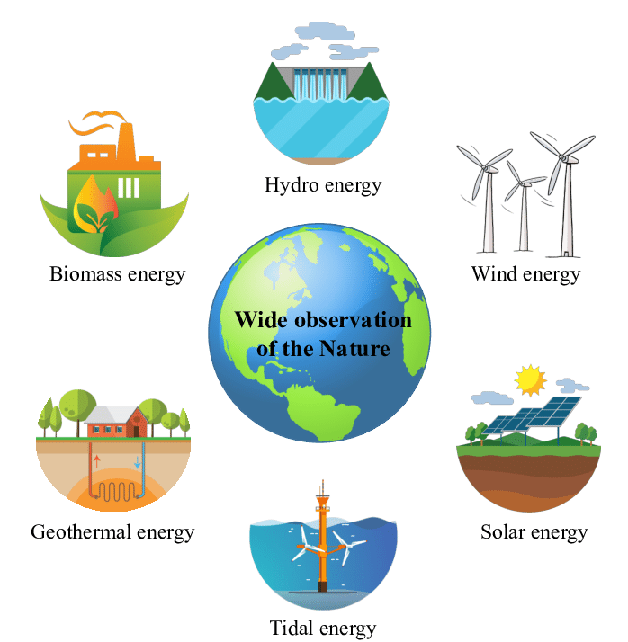

__________________________________________________________________

# UNIT-III

1. Discuss the factors affecting fabric heat loss in a building.

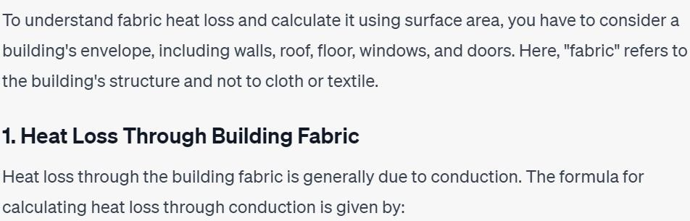

# Q = U × A × ΔT

Where; Q = Heat loss (Watt or W)

U = Coefficient of Heat transmission (W/m2 k)

A = Surface Area (m2)

ΔT = Temperature difference between outside and inside of a building (K or °C)

**Factors affecting fabric heat loss:**

1. ***U-Value:*** This measures how effective a building material is as an insulator. Lower U-values indicate better insulation.

Different materials have varying levels of thermal conductivity. Materials with higher thermal conductivity allow heat to pass through more easily, leading to increased heat loss.

1. ***Surface Area:*** As mentioned earlier, a larger surface area results in more heat loss, as there is more space for heat to escape.
2. ***Temperature Difference:*** The greater the temperature difference between the inside and outside of a structure, the higher the heat loss through the fabric.
3. ***Thickness of the Fabric:*** Thicker fabrics generally provide more insulation and resist heat loss better than thinner ones.
4. ***Thermal Bridging:*** It occurs when there's a break in insulation, like through studs in walls or metal connections, allowing heat to flow more easily.
5. ***Air Leakage:*** Gaps and cracks in the building envelope can lead to air leakage, which carries heat away.
6. ***Orientation:*** The direction a building faces can impact how much sunlight it receives and how much heat is lost through its surfaces.
7. ***Climatic Conditions:*** Wind increases the rate of heat loss by carrying away the heat that accumulates near the fabric's surface.

High humidity levels can affect heat loss by affecting the fabric's thermal properties and promoting heat transfer through moisture.

__________________________________________________________________

1. How the natural energy is utilized for development of Building Form.

**UTILIZING NATURAL ENERGY:**

Utilizing natural energy, also known as passive design or passive solar design, involves harnessing the energy provided by the sun, wind, and other natural elements to enhance the energy efficiency and comfort of buildings. This approach minimizes the reliance on mechanical systems and maximizes the benefits of local climate conditions.

1. ***Solar Energy:***

Passive solar design takes advantage of the sun's energy for heating and lighting. Key principles include:

* + Orientation: Position the building to maximize south-facing exposure in the Northern Hemisphere (or north-facing in the Southern Hemisphere) to capture the most sunlight during the colder months.
  + Solar Heat Gain: Incorporate well-insulated windows on the sun-facing side to allow sunlight to penetrate and warm the interior spaces.
  + Thermal Mass: Use materials with high thermal mass, like concrete or stone, to absorb and store heat from sunlight, releasing it slowly to maintain a comfortable temperature.

1. ***Daylighting:***

Design for natural daylighting to reduce the need for artificial lighting:

* + Window Placement: Place windows strategically to allow for even distribution of natural light throughout the building.
  + Light Shelves and Reflectors: Use architectural features like light shelves and reflectors to bounce and redirect sunlight deeper into the building.

1. ***Natural Ventilation:***

Passive cooling through natural ventilation reduces the need for mechanical cooling systems:

* + Cross-Ventilation: Design openings on opposite sides of the building to facilitate the movement of fresh air through spaces, promoting cooling.
  + Stack Effect: Utilize the difference in air density to create a natural upward flow of warm air, drawing cooler air from lower openings.

1. ***Shading and Overhangs:***

Proper shading helps prevent overheating and excessive solar gain:

* + Eaves and Awnings: Design extended eaves or awnings that provide shade to windows during the hottest parts of the day.
  + Louvers and Sunscreens: Incorporate adjustable shading devices that can be adapted to changing solar angles.

1. ***Wind Energy:***

In areas with consistent wind patterns, natural ventilation and wind-driven ventilation strategies can reduce cooling demands:

* + Ventilation Openings: Design openings to allow prevailing winds to pass through and promote passive cooling.
  + Ventilation Towers: Incorporate vertical ventilation towers or chimneys that encourage air movement through convection.

1. ***Cooling Courtyards and Water Features:***

Courtyards with vegetation and water elements can provide cooling through evapotranspiration and creating a microclimate of comfort.

1. ***Green Roofs and Walls:***

Vegetated roofs and walls contribute to thermal insulation, absorb rainwater, and provide cooling effects.

1. ***Site-Specific Design:***

Tailor passive design strategies to the local climate, topography, and vegetation, ensuring that the building responds effectively to its surroundings.

__________________________________________________________________

1. Define Building Forms. Write about the factors influencing it.

**BUILDING FORMS:**

Building forms in the context of green buildings refers to the design and layout of a structure, taking into consideration energy efficiency, sustainability, and environmental impact.

Here are the key points to consider when building forms for green buildings:

1. ***Orientation and Layout:*** The orientation of the building plays a crucial role in maximizing natural light and minimizing heat gain. Design the building's layout to take advantage of prevailing winds, sun angles, and shading to reduce the need for artificial lighting and cooling.
2. ***Shape and Massing:*** The shape and massing of the building can impact its energy consumption. Compact forms with minimal surface area exposed to the outside reduce heat loss in winter and heat gain in summer.
3. ***Envelope Design:*** Building envelope (walls, roofs, windows) should be wellinsulated & have high thermal resistance to prevent heat transfer. Energy-efficient windows and consider incorporating shading devices to control solar heat gain.
4. ***Materials Selection:*** Opt for sustainable and locally sourced materials with low embodied energy. Choose materials that have a lower environmental impact, are recyclable, and have a longer lifespan.
5. ***Day lighting:*** Design the building with ample windows and skylights to maximize natural daylight. This reduces the need for artificial lighting during the day, which saves energy and enhances occupants' well-being.
6. ***Passive Solar Design:*** Incorporate passive solar design principles, such as using thermal mass (materials that absorb and release heat) to regulate indoor temperatures and harnessing solar energy for heating.
7. ***Ventilation and Airflow:*** Plan for natural ventilation by positioning windows to facilitate cross-ventilation. This reduces the reliance on mechanical ventilation systems, leading to energy savings.
8. ***Renewable Energy Integration:*** Integrating renewable energy sources like solar panels, wind turbines & geothermal systems to power the building.
9. ***Life Cycle Assessment:*** Consider the life cycle impact of materials and design decisions, including construction, operation, and end-of-life considerations.

***Certification Standards:*** Adhere to recognized green building certification standards like LEED (Leadership in Energy and Environmental Design) or BREEAM (Building Research Establishment Environmental Assessment Method) to ensure your building meets rigorous sustainability criteria. __________________________________________________________________

1. Determine the total heat loss from the building whose Area is 107.67 sq.ft, coefficient of heat transfer is 0.7 W/m2K and the temperature difference is 25C.

To determine the total heat loss from the building, you can use the formula:

Q = U x A x T

**where:**

Q is the total heat loss (in watts),

U is the coefficient of heat transfer (in W/m²K),

A is the area (in m²),

T is the temperature difference (in °C).

**1. Convert the area from square feet to square meters:**

1 sq.ft = 0.092903 m²

A = 107.67 sq.ft x 0.092903 m²/sq.ft = 10.000 m²

**2. Use the given values:**

U = 0.7 W/m²K

T = 25 °C

**3. Calculate Q:**

Q = 0.7 W/m²K x 10.000 m² x 25 K

Q = 0.7 x 10.000 x 25 = 1750 W

So, the total heat loss from the building is **1750 watts.**

__________________________________________________________________

1. Determine the total heat loss from the building whose Area is 20 sq.m, coefficient of heat transfer is 0.5 W/m2K and the temperature difference is 30C.

**To determine the total heat loss from the building, we again use the formula:**

Q = U x A x T

**Where:**

Q is the total heat loss (in watts),

U is the coefficient of heat transfer (in W/m²K),

A is the area (in m²),

T is the temperature difference (in °C).

**Given:**

A = 20 m²,

U = 0.5 W/m²K,

T = 30 °C.

**Now, calculate the heat loss:**

Q = 0.5 W/m²K x 20 m² x 30 K

Q = 0.5 x 20 x 30 = 300 W

**So, the total heat loss from the building is 300 watts**

Last Edited on 19-09-2024 23:28:54  
 Mr_immortal